Milestone 1

Project 5: Sales Forecasting and Demand Prediction

|  |
| --- |
| Abdelwahab Amr |
| Mohamed Salah |
| Khaled Hany |
| Omar Ahmed |
| Hatem |
|  |

**EDA:**

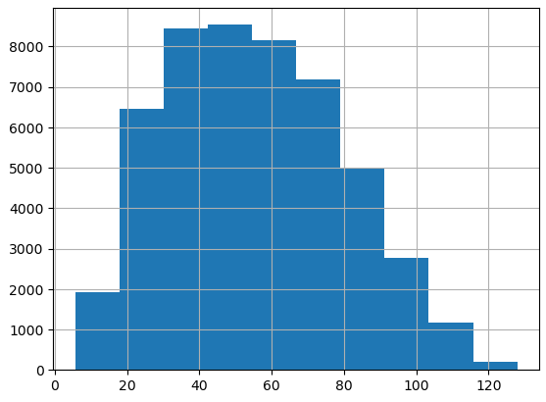

Based on the graph above for the total prices, the graph seems symmetrical meaning the mean similar to the median similar to the mode and the range is between 40$ and 60$.

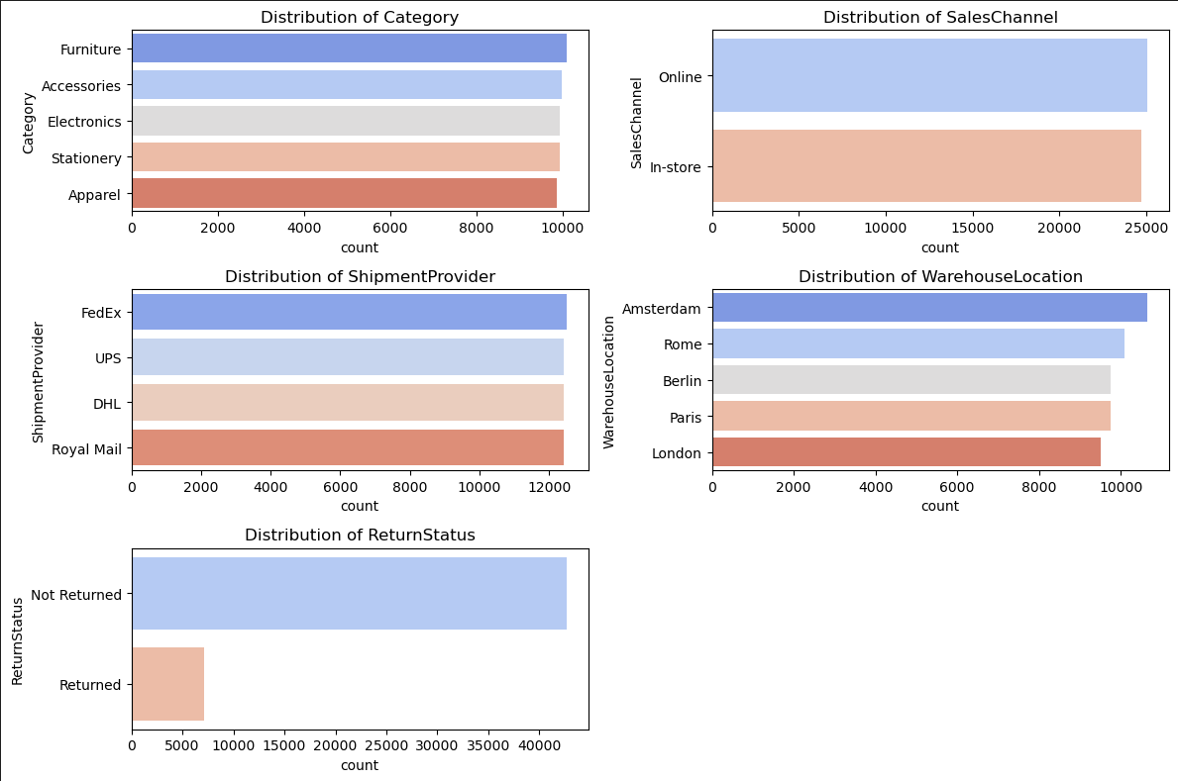

Based on these graphs we can see in the first graph that furniture is slightly above the others in terms of stock making it the largest in terms of stock among the other categories.

We can also see in the second graph that people who make online purchases are slightly more than in-store purchases.

And in the third graph, we can see that FedEx is slightly more used than the other shipment providers.

In the fourth graph, the Amsterdam warehouse location holds the most stock than any other warehouse, after that is Rome, then Berlin and Paris, and the least stocked warehouse is London, which might mean that most people in London prefer buying in-store.

And lastly, in the last graph we can see the most people don’t prefer to return their product.

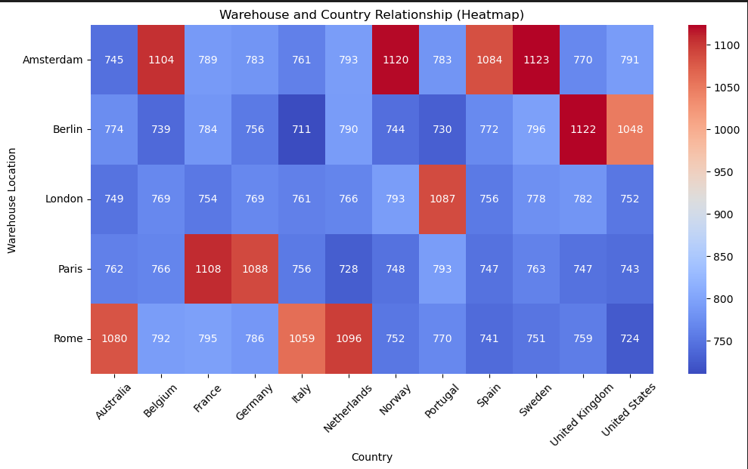

Based on this heatmap we can see that Paris and Rome handle a high number of shipments to France and Italy respectively.

Amsterdam and Berlin have strong shipment activity to multiple countries, but some countries have significantly higher shipments like United Kingdom and United States for Berlin.

London and Berlin seem to have evenly spread shipments across multiple countries, without a single country dominating.

Rome, Paris, and Amsterdam seem to have the darkest red regions, indicating they handle the most shipments in general.

Berlin and London have fewer intense red zones, meaning they may serve a wider but lower-volume customer base.

Based on these findings we can say that if we want to optimize logistics, we could add another warehouse in France or Italy.

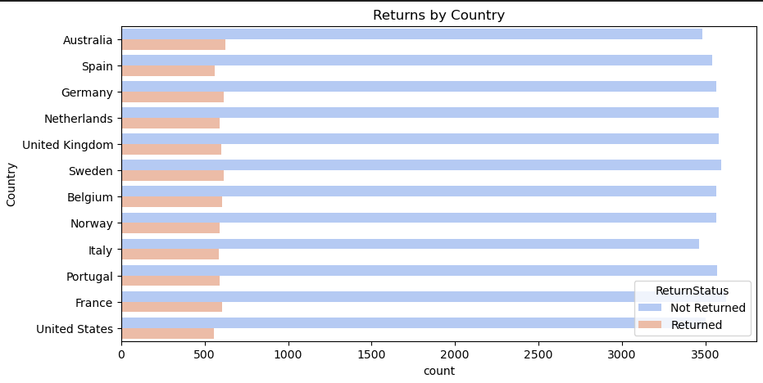

Based on this graph we can see that when it comes to returns, they are generally low and almost comparable, which indicates that returns are not influenced by geographical factors.

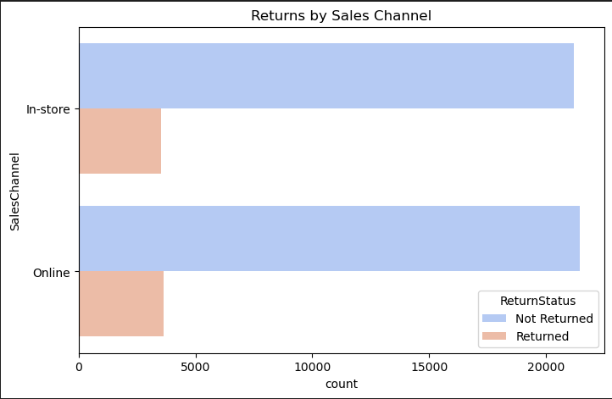

Based on this graph we can see the both in-store purchases and online are almost equal in terms or return status, however online purchases are slightly higher as well as online returns, which would suggest that people generally buy more online and some products might not meet expectations or might be returned due to other reasons, like broken while delivery.

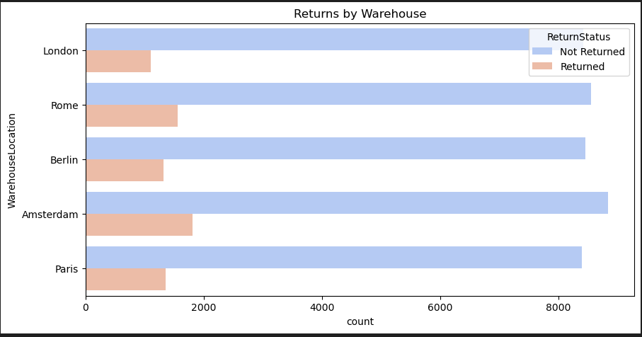

Based on this graph and a previous graph, we see a pattern that warehouse with more stock tends to have more orders resulting in more returns, since before we saw that Amsterdam after that Rome had the most stock, and now they have the most returns.

However, based on the data we can also see that the returns are proportionate to the amount of cargo and orders each warehouse has, in other words the country with the most cargo and orders had the most returns and the country with the least cargo and orders had the least returns.

Nevertheless, if we focus into Rome, we can see that its proportions are slightly off, which could mean that there could possibly be some problems in handling the products in the warehouse or maybe something related to regional differences.

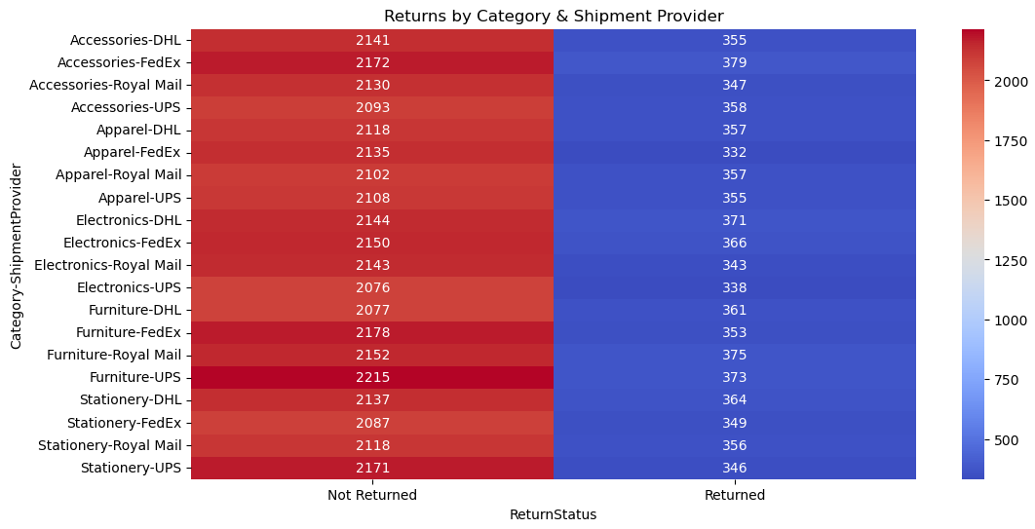

Based on this heatmap we can see that the row Furniture-UPS has the highest number of orders and also the highest number of unreturned products, which suggests that there is high demand for furniture shipped by UPS and that UPS handles the furniture shipments well compared to other.

On the other hand, the highest number of returns are in FedEx, especially for furniture and electronics. This indicates that FedEx could have poor handling of products compared to other.

We could also see that electronics has the highest return rate, which suggests that electronics might be damaged upon arrivals.

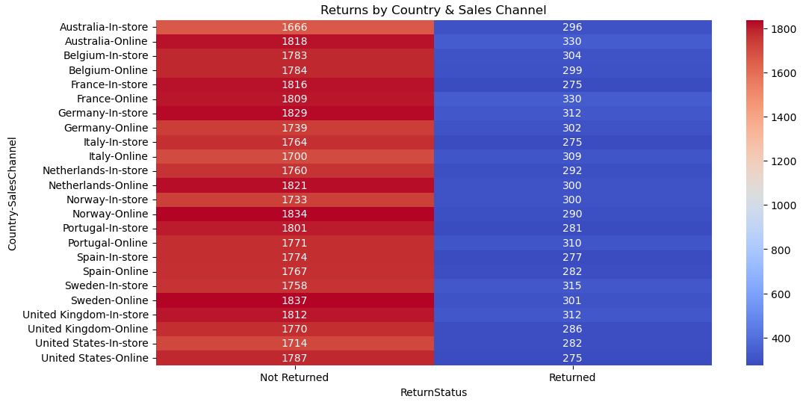

Based on this figure, we can see that countries like Norway, Sweden, Australia, and Netherlands have more returns in online sales compared to in-store. This could suggest that returns are more driven by sales channels than warehouses.

In previous graphs, we saw that Amsterdam and Rome had the highest returns, now we can see that Netherlands and Italy, which are linked to those warehouses, have large number of online sales and returns.

Which means that returns are more influenced by online shopping than warehouse efficiency.

Also, Germany and France have the lowest returns, which might mean higher customer satisfaction.

On the other hand, Sweden-Online has the highest return count, which suggests poor handling of shipments or that customers tend to return more often.